DOCKER

MONOLITHIC:

If an application contains N number of services (Let's take Paytm has Money Transactions, Movie Tickets, Train tickets, etc..) If all these services are included in one server then it will be called Monolithic Architecture. Every monolithic Architecture has only one database for all the services.

MICRO SERVICES:

If an application contains N number of services (Let's take Paytm has Money Transactions, Movie Tickets, Train tickets, etc..) if every service has its own individual servers then it is called microservices. Every microservice architecture has its own database for each service.

WHY DOCKER:

let us assume that we are developing an application, and every application has front end, backend and Database.

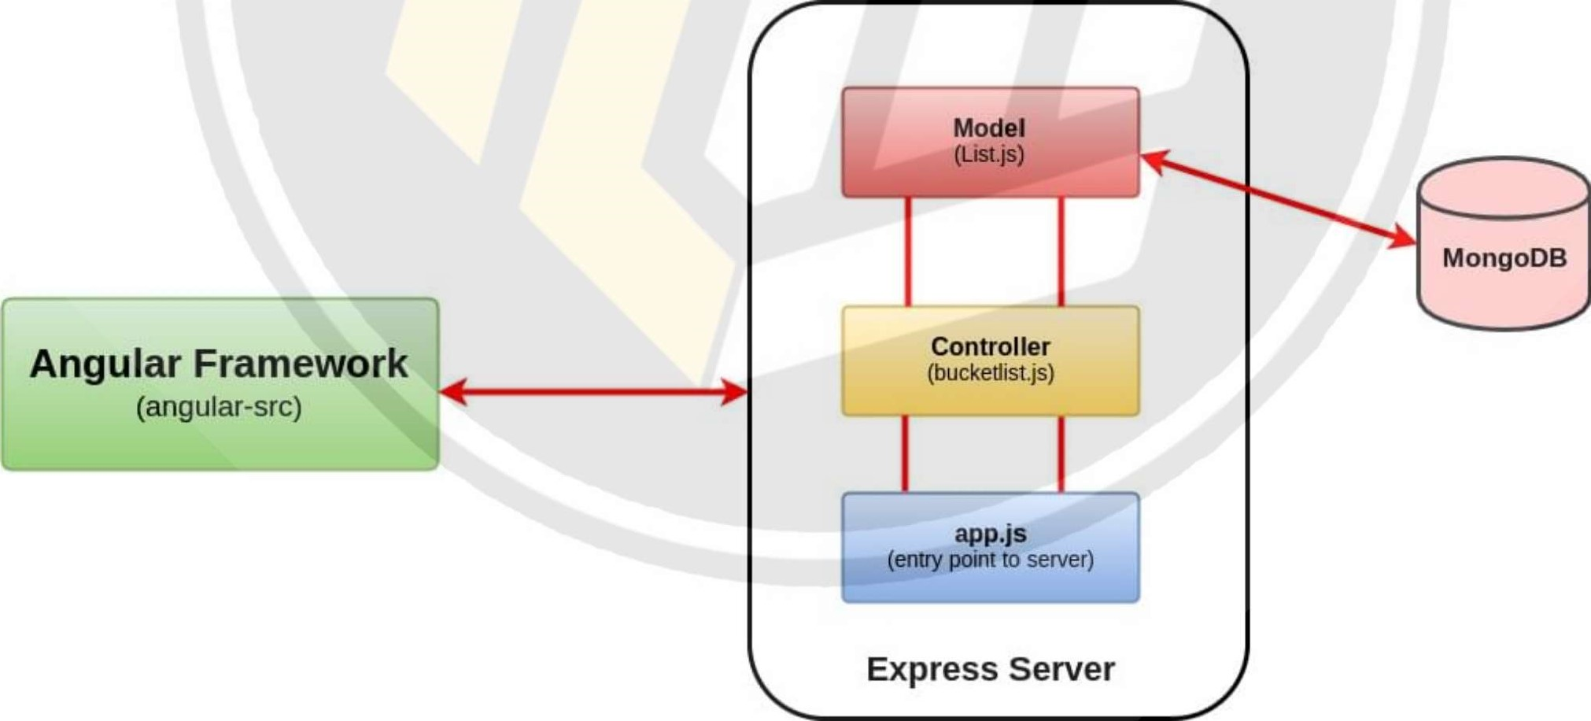

To develop the application we need install those dependencies to run to the code.

So i installed Javall, ReactJS and MongoDB to run the code.

After some time, i need another versions of java, react and mongo DB for my application to run the code.

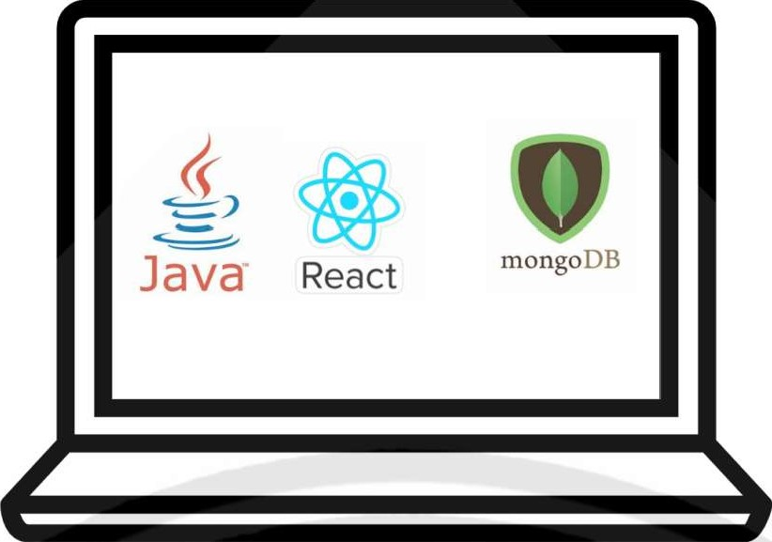

So its really a hectic situation to maintain multiple versions of same tool in our system. To overcome this problem we will use virtualization.

VIRTUALISATION:

It is used to create a virtual machines inside on our machine. in that virtual machines we can hots guest OS in our machine.

by using this Guest OS we can run multiple application on same machine. Hypervisor is used

to create the virtualisation.

|  |
| --- |
| APP 3 |
| BINS/ LIBS |
|  |

|  |
| --- |
| APP 2 |

|  |  |  |
| --- | --- | --- |
| BINS/ LIBS |  | BINS/ |
|  |

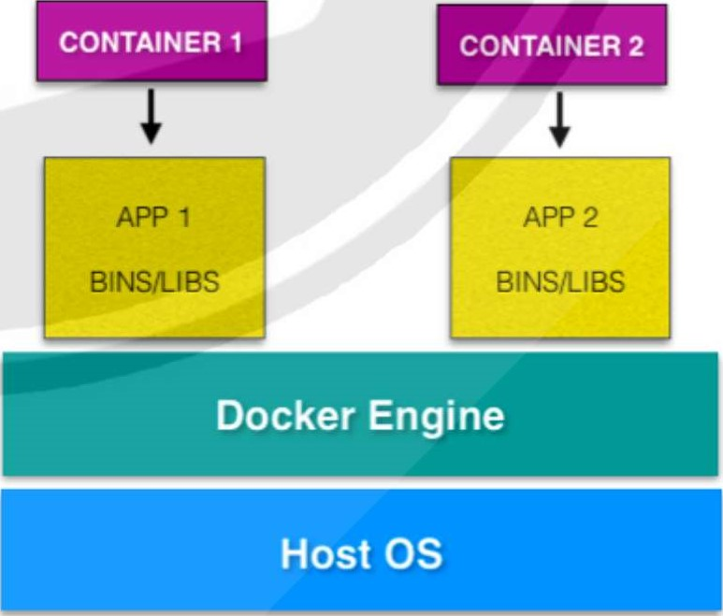APP 1

Hypervisor

VIRTUAL MACHINE ARCHITECTURE

DOCKER ARCHITECTURE

DRAWBACKS:

* It is old method.
* If we use multiple guest OS then the performance of the system is low.

CONTAINERIZATION: It is used to pack the application along with its dependencies to run the application.

CONTAINER:

* Container is nothing but, it is a virtual machine which does not have any OS.
* Docker is used to create these containers.
* A container is like a lightweight, standalone package that contains everything needed to run a piece of software.
* It includes the application code, runtime, system libraries, and dependencies.  To create a container we use docker.

DOCKER

* It is an open source centralized platform designed to create, deploy and run applications.
* Docker is written in the Go language.
* Docker uses containers on host O.S to run applications. It allows applications to use the same Linux kernel as a system on the host computer, rather than creating a whole virtual
* We can install Docker on any O.S but the docker engine runs natively on Linux distribution.
* Docker performs O.S level Virtualization also known as Containerization.
* Before Docker many users face problems that a particular code is running in the developer's system but not in the user system.
* It was initially released in March 2013, and developed by Solomon Hykes and Sebastian Pahl.
* Docker is a set of platform-as-a-service that use O.S level Virtualization, where as VM ware uses Hardware level Virtualization.
* Container have O.S files but its negligible in size compared to original files of that O.S.

DOCKER ARCHITECTURE:

DOCKER COMPONENTS



|  |  |  |  |  |  |
| --- | --- | --- | --- | --- | --- |
| Client   |  | | --- | | docker build | |  | DOCKER HOST |  | ORACLE |
|  | Docker daemon |

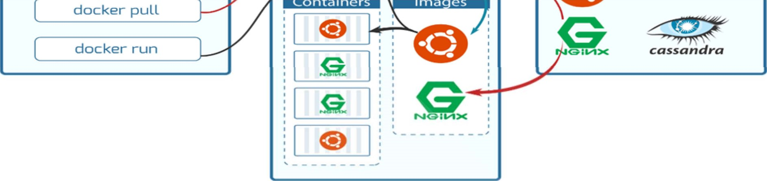

DOCKER CLIENT:

It is the primary way that many Docker users interact with Docker. When you use commands such as docker run, the client sends these commands to docker daemon, which carries them out. The docker command uses the Docker API.

DOCKER HOST:

Docker host is the machine where you installed the docker engine.

DOCKER DAEMON:

Docker daemon runs on the host operating system. It is responsible for running containers to manage docker services. Docker daemon communicates with other daemons. It offers various Docker objects such as images, containers, networking, and storage.

DOCKER REGISTYR:

A Docker registry is a place where Docker images are stored and can be easily shared. It serves as a centralized repository for Docker images, allowing users to upload, download, and manage container images.

POINTS TO BE FOLLOWED:

* You cant use docker directly, you need to start/restart first (observe the docker version before and after restart)
* You need a base image for creating a Container.
* You cant enter directly to Container, you need to start first.  If you run an image, By default one container will create.

DOCKER BASIC COMMANDS:

* To install docker in Linux : yum install docker -y
* To see the docker version : docker --version
* To start the docker service : service docker start
* To check service is start or not : service docker status
* To check the docker information : docker info
* To see all images in local machine : docker images
* To find images in docker hub : docker search image name
* To download image from docker hub to local : docker pull image name
* To download and run image at a time : docker run -it image name /bin/bash  To give names of a container : docker run -it --name raham img-name /bin/bash
* To start container : docker start container name
* To go inside the container : docker attach container name
* To see all the details inside container : cat /etc/os-release
* To get outside of the container : exit
* To see all containers : docker ps -a
* To see only running containers : docker ps (ps: process status)
* To see only exited containers: docker ps -q -f "state=exited"
* To stop the container : docker stop container name
* To delete container : docker rm container name
* To stop all the containers : docker stop $(docker ps -a -q)
* To delete all the stopped containers : docker rm $(docker ps -a -q)  To delete all images : docker rmi -f $(docker images -q)

DOCKER RENAME: is used to rename the container.

To rename docker container: docker rename old_container new_container

HOW TO CHANGE DOCKER PORT NUMBER:

* stop the container  go to path (var/lib/docker/container/container_id)  open hostconfig.json  edit port number  restart docker and start container

DOCKER EXPORT: is a command in Docker that allows you to save a Docker container as a tarball archive file. This tarball contains the container's file system and can be used to transfer the container to another system or share it with others.

Create a file which contains will gets stored: touch docker/password/secrets/filel.txt

TO EXPORT: docker export -o docker/password/secrets/filel.txt container_name

SYNTAX: docker export -o path container

ALTERNATE CONTAINER COMMANDS:

* To see list of containers : docker container Is
* To see all running containers: docker container Is -a
* To see latest 2 containers : docker container Is -n 2
* To see latest container : docker container Is --latest
* To see all container id's : docker Is -a -q
* To remove all containers : docker container rm -f $(docker container Is -aq)
* To see containers with sizes : docker container Is -a -s
* To stop container after some time: docker stop -t 60 cont_id

KILL VS STOP:

KILL: It passes SIGKILL signal to the container.

STOP: It passes SIGTERM signal to the container.

RUNNING A CONTAINER:

* docker run --name contl -d nginx e docker inspect contl  curl container_private_ip:80  docker run --name cont2 -d -p 8081(hostport):80(container port) nginx

DOCKER EXEC: is a command that allows you to run commands inside a running Docker container. You can use docker exec to execute commands, check the container's file system, troubleshoot issues, or perform various tasks within the container without the need to start a new instance of the container.

syntax - docker exec cont_name command ex-I: docker exec contl Is ex-2: docker exec cont mkdir devops

to enter into container: docker exec -it cont_name /bin/bash or docker exec -it cont_name bash

LIMITS TO CONTAINER: It is used to set a memory limits to containers

* docker run -dit --name cont_name --memory=250m image_name e to check: docker inspect cont_name I grep -i memory  to check: docker inspect cont_name I grep -i nanocpu

CREATE IMAGE FROM CONTAINER:

* First it should have a base image - docker run nginx
* Now create a container from that image - docker run -it --name container_name image_name /bin/bash
* Now start and attach the container o go to tmp folder and create some files (if you want to see the what changes has made in that image - docker diff container_name)  exit from the container  now create a new image from the container - docker commit container_name new_image_name
* Now see the images list - docker images  Now create a container using the new image  start and attach that new container  see the files in tmp folder that you created in first container.

DOCKER FILE:

* It is basically a text file which contains some set of instructions.
* Automation of Docker image creation.
* Always D is capital letters on Docker file.
* And Start Components also be Capital letter.

HOW IT WORKS:

* First you need to create a Docker file
* Build it
* Create a container using the image

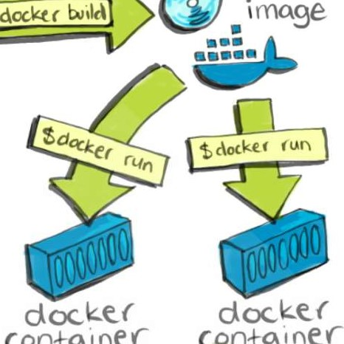

Con+Q

i

ne

Con+Q

docker

DOCKER FILE COMPONENTS:

* FROM: For base image this command must be on top of the file. Ex: ubuntu, Redis, Jenkins
* LABEL: Labeling like EMAIL, AUTHOR, image description etc.
* RUN: To execute commands while we build the image.
* COPY: Copy files/folders from local system to container where need to provide Source and Destination.
* ADD: it is also used to copy the files and also It can download files from the internet and and send the files to container.
* EXPOSE: To expose ports such as 8080 for tomcat and port 80 nginx etc.
* WORKDIR: To set working directory for the Container.
* CMD: Executes commands but during Container creation.
* ENTRYPOINT: The command that executes inside of a container. like running the services in a container.
* ENV: Environment Variables.
* ARG: Used to pass Environment variables.

COMPARISIONS•.

ENV vs ARG

* ARG argument is not available inside the Docker containers.  ENV argument is accessible inside the container

RUN vs CMD vs ENTRYPOINT:

* RUN: it is used to execute the commands while we build the images and add a new layer into the image.
* CMD: it is used to execute the commands when we run the container. if we have multiple CMD's only last one will gets executed.
* ENTRY POINT: it overwrites the CMD when you pass additional parameters while running the container.

COPY vs ADD:

* COPY: Used to copy local files to containers
* ADD: Used to copy files form internet and extract them

STOP vs KILL:

* STOP: attempts to gracefully shutdown container, issues a SIGTERM signal to the main process.
* KILL: immediately stops/terminates them, while docker kill (by default) issues a SIGKILL signal.

PULL vs RUN:

* PULL: It is used to download the images from docker registry  RUN: It is used to create a container.

EXPOSE VS PUBLISH:



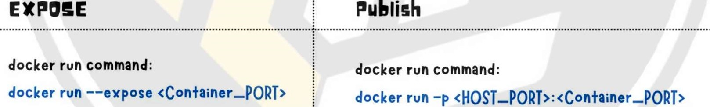

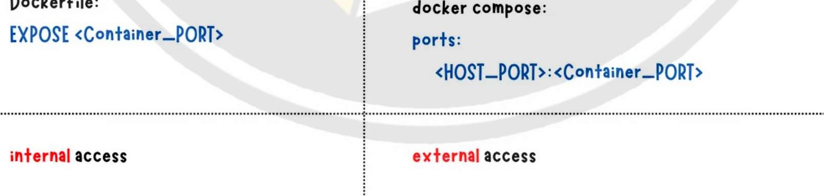

DockerFiIe:

compose:

DOCKER FILE TO CREATE AN IMAGE:

FROM ubuntu

touch aws devops linux

TO BUILD: docker build -t image_name . (. represents current directory)

FROM . ubuntu

. touch aws devops linux echo "hello world">/tmp/filel

Now see the image and create a new container using this image. Go to container and see the files that you created.

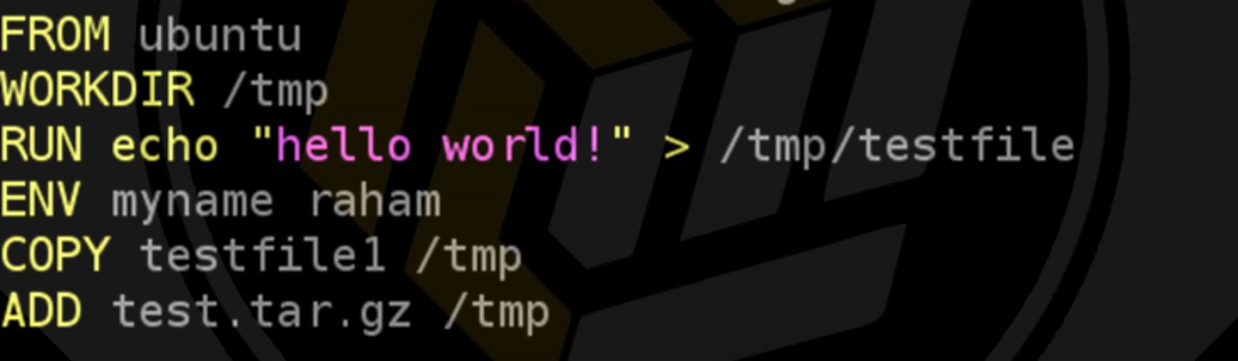

[ root@ip- 172-31-83-27 touch test file 1

[ root@ip- 172-31-83-27 touch test

[ root@ip-172-31-83-27 Is

Docke rfile test testfilel

[root@ip- 172-31-83-27 tar -cvf test. tar test test

[ root@ip- 172-31-83-27 Is

Docke rfile test testfilel test . tar

[ root@ip-172-31-83-27 gzip test. tar

[root@ip- 172-31-83-27 Is

Docke rfile test test file 1 test . tar.gz

[ root@ip-172-31-83-27 rm -rf test



DOCKER FILE TO INSTALL NGINX ON UBUNTU:

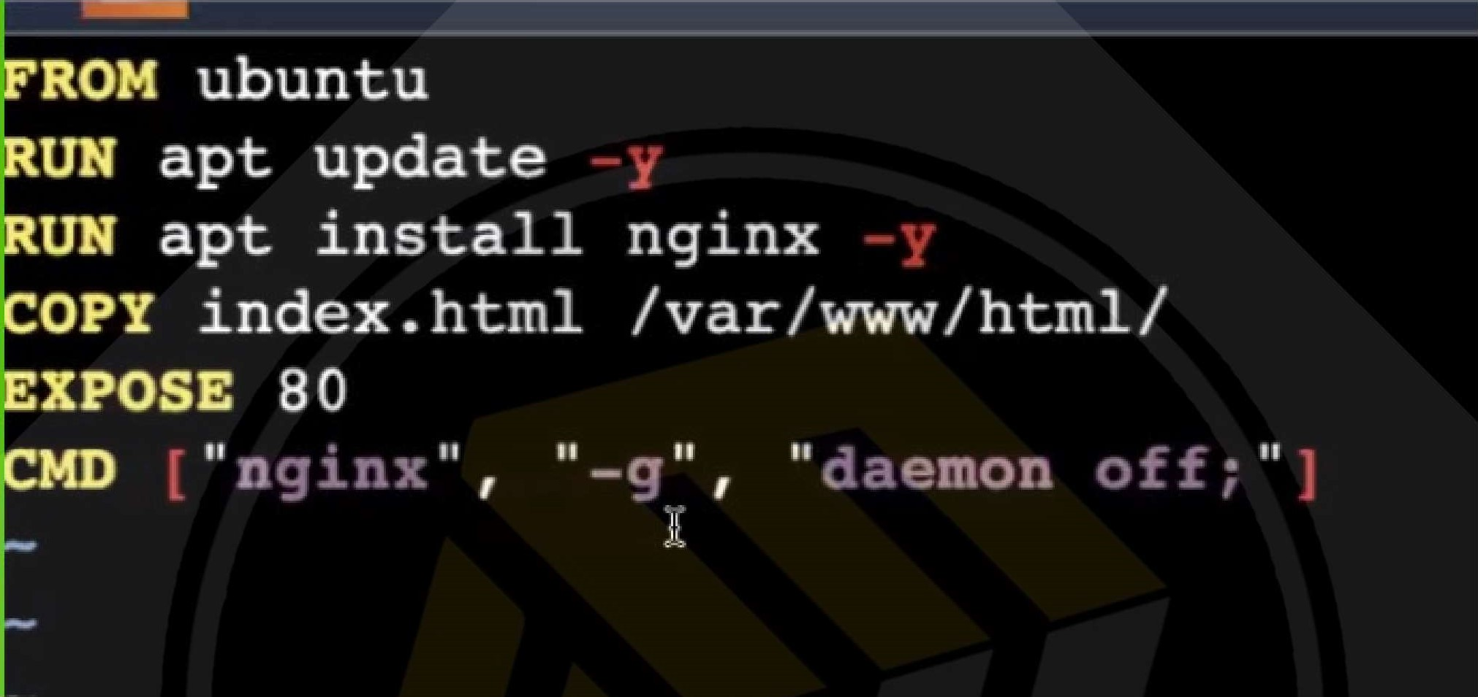

DOCKER FILE TO INSTALL APACHE2 ON UBUNTU:

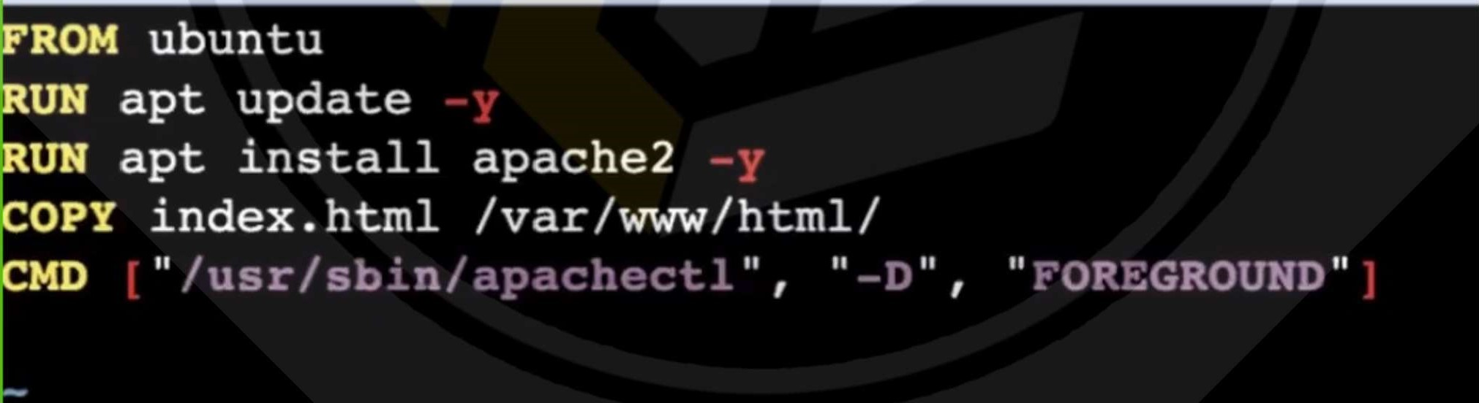

DOCKER FILE TO INSTALL HTTPD ON CENTOS

FROM centos : centos 7

MAINTAINER name mustafa

RUN yum install httpd

COPY index. html /var/www/html/

EXPOSE 80

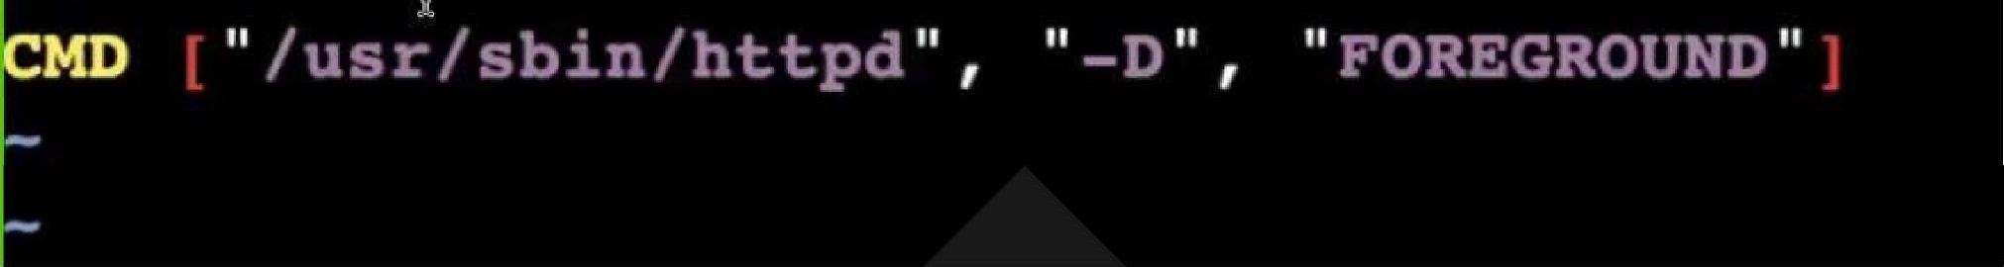

DOCKER FILE TO USE NGINX IMAGE

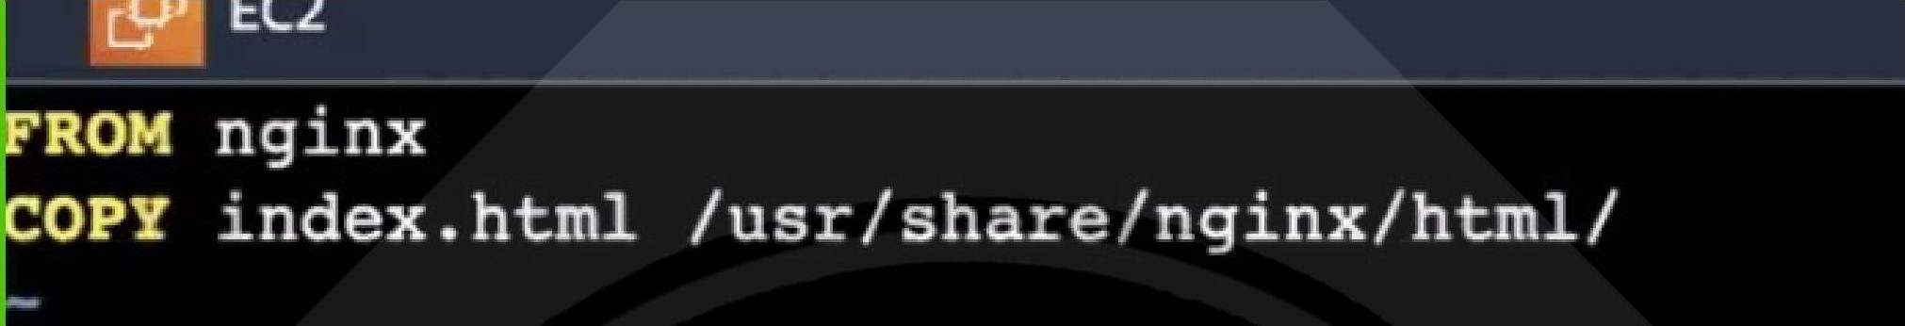

DOCKER VOLUMES:

* When we create a Container then Volume will be created.
* Volume is simply a directory inside our container.
* First, we have to declare the directory Volume and then share Volume.
* Even if we stop/delete the container still, we can access the volume.
* You can declare directory as a volume only while creating container.
* We can't create volume from existing container.
* You can share one volume across many number of Containers.
* Volume will not be included when you update an image.
* If Container-I volume is shared to Container-2 the changes made by Container-2 will be also available in the Container-I.

You can map Volume in two ways:

1. Container < > Container
2. Host < > Container

USES OF VOLUMES:

* + Decoupling Container from storage.
  + Share Volume among different Containers.
  + Attach Volume to Containers.
  + On deleting Container Volume will not be deleted.

CREATING A VOLUME FROM DOCKER FILE:

* + Create a Docker file and write

FROM ubuntu

VOLUME["/myvolume"]

* + build it - docker build -t image_name .
  + Run it - docker run -it - -name containerl ubuntu /bin/bash
  + Now do Is and you will see myvolume-l add some files there
  + Now share volume with another Container - docker run -it - -name container2(new) - privileged-true - -volumes-from containerl ubuntu  Now after creating container2, my volumel is visible
  + Whatever you do in volumel in containerl can see in another container  touch /myvolumel/samplefilel and exit from container2.  docker start containerl  docker attach containerl
  + Is/volumel and you will see your samplefilel

CREATING VOLUMES FROM COMMAND:

VOLUMES (HOST TO CONTAINER):

* + Verify files in /home/ec2-use  docker run -it - -name hostcont -v /home/ec2-user:/raham - -privileged-true ubuntu  cd raham [raham is (container-name)]
  + Do Is now you can see all files of host machine.
  + Touch filel and exit. Check in ec2-machine you can see that file.

SOME OTHER COMMANDS IN VOLUMES:

* + docker volume Is  docker volume create <volume-name>  docker volume rm <volume-name>  docker volume prune (it will remove all unused docker volumes).  docker volume inspect <volume-name>  docker container inspect <container-name>  docker system df -v

MOUNT VOLUMES:

* + To attach a volume to a container: docker run -it --name=examplel --mount source=voll,destination=/voll ubuntu
  + To send some files from local to container: o create some files o docker run -it --name cont_name -v "$(pwd)":/my-volume ubuntu
  + To remove the volume: docker volume rm volume_name  To remove all unused volumes: docker volume prune

BASE VOLUME:

* + create a volume : docker volume create volume99(volume-name)  mount it: docker run -it -v volume99:/my-volume --name containerl ubuntu  now go to my-volume and create some files over there and exit from container  mount it: docker run -it -v volume99:/my-volume-01 --name container2 ubuntu

DOCKER REGISTYR•.

Docker registry is a place where Docker images are stored and can be easily accessed. There are two types of docker registries

1. Cloud based registry : DockerHub, ACR (Amazon Container Registry), GCR (Google Container Registry), ACR (Azure container Registry).
2. Local registry : Jfrog, Nexus, DTR (Docker Trusted Registry).

By default docker hub is the default registry.

Docker Hub is a cloud-based platform that allows developers to store and share their Docker container images. A Docker container is a lightweight, standalone, and executable package that includes everything needed to run a piece of software, including the code, runtime, libraries, and system tools.

DOCKER PUSH:

It is a command used in Docker, a containerization platform, to upload or "push" your Docker image to a container registry.

STEPS TO PUSH DOCKER IMAGE:

* + Clone any repo with Dockerfile
  + Build the docker file : docker build -t imagel .  now create a docker hub account
  + Now log into the docker hub by using docker login.
  + Enter username and password.
  + Now give the tag to your image, without tagging we can't push our image to docker.  docker tag imagel shaikmustafa/my-repo:imagel (ex: projectl)  docker push shaikmustafa/my-repo:imagel
  + Now you can see this image in the docker hub account.
  + Now create one instance in another region and pull the image from the hub.  docker pull shaikmustafa/my-repo:imagel  docker run -it - -name mycontainer shaikmustafa/my-repo:imagel /bin/bash  Now go to docker hub and select your image -- > settings -- > make it private.  Now run docker pull shaikmustafa/my-repo:imagel  If it is denied then login again and run it.
  + If you want to delete image settings -- > projectl -- > delete

DOCKER NETWORKS:

Docker networking is primarily used to establish communication between Docker containers and the outside world. Docker supports different types of networks.

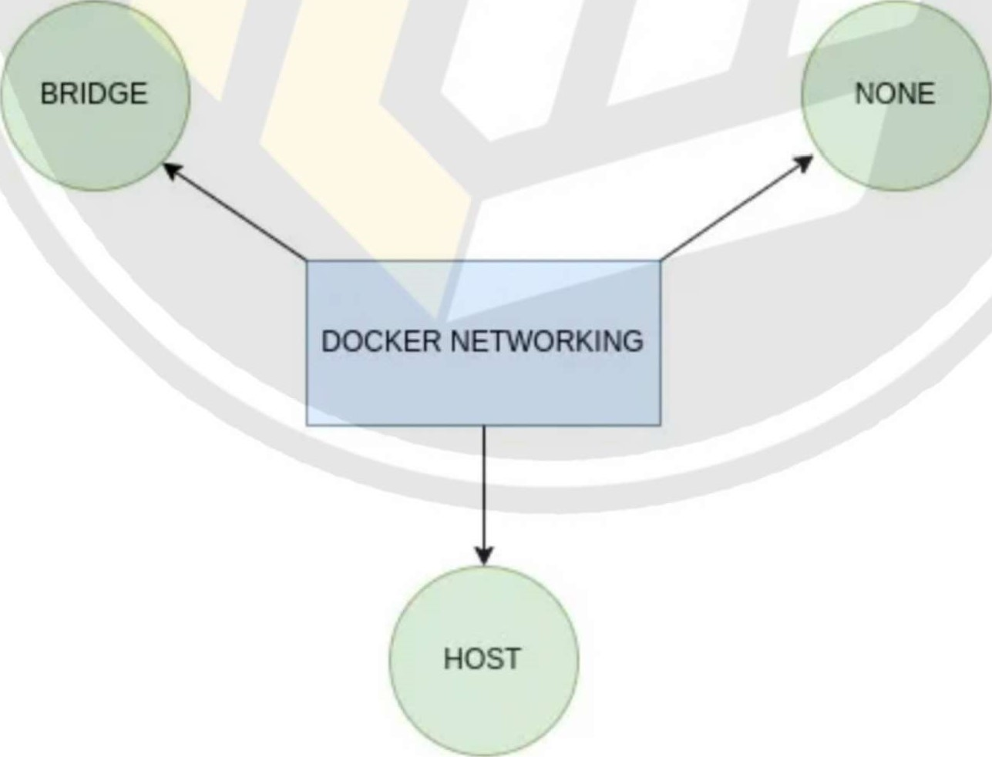

networks

When we install Docker, it created three networks automatically.

1. Bridge
2. None
3. Host
4. OverLay

BRIDGE NETWORK:

Bridge is the default network a container gets attached to. It is a private internal network created by Docker on the host. Eah container connecting to this network get their own internal private network address. Generally IPS get assigned in the range of 172.17.x.x to the containers. The containers can access each other using the internal 'P. If we want to access any of these containers from the outside world, then we need to map the ports of these containers to ports on the Docker host. The another name of Bridge network is dockerO as it's the default one.

NONE NETWORK:

With a none network the docker container is not attached to any other network. The container can not reach to the outside world and no one from the outside world can access the container. We can use it when we want to disable the networking on a container.

HOST NETWORK:

If we want to access the containers externally, then we can attach the container to Host network. There is no network isolation between the host and the container. That means like bridge network we don't need to any additional port mapping. For example, If we deploy a web app which is listening on port 80 , then it will be accessible on port 80 on the host. But we will now not be able to run multiple web containers on the same host and the same port. If we try to run another instance of our web app that listens on the same port, it won't work as they share the host networking and two processes can't listen on the same port at the same time.

OVERLAY NETWORK:

Used to communicate containers with each other across the multiple docker hosts.

DOCKER NETWORK COMMANDS:

* To create a network: docker network create network_name
* To see the list: docker network Is
* To delete a network: docker network rm network_name
* To inspect: docker network inspect network_name
* To connect a container to the network: docker network connect networkName contName  apt install iputils-ping -y : command to install ping checks
* To disconnect from the container: docker network disconnect NetworkName contName  To prune: docker network prune

# DOCKER FILE TO DEPLOY WAR FILE

FROM tomcat: 8.0.20-jre8

COPY tomcat—users .xml /usr/local/tomcat/conf/

COPY target/ * . war /usr/local/tomcat/webapps/myweb. war

DOCKER FILE TO DEPLOY NODE JS FILE:

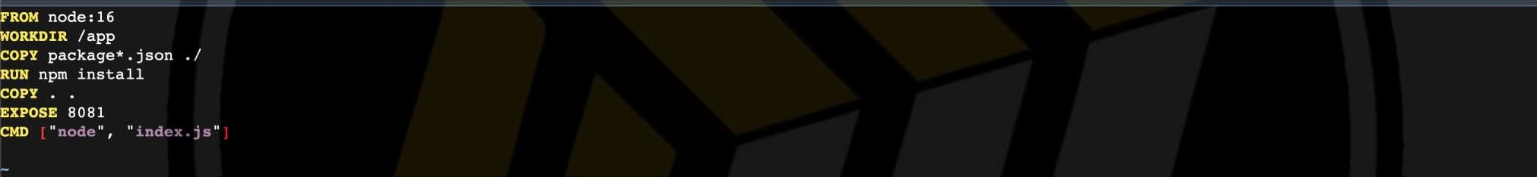

REFERENCE: https://github.com/devops0014/nodejs-docker.git

DOCKER SWARM:

* Docker swarm is an orchestration service within docker that allows us to manage and handle multiple containers at the same time.
* It is a group of servers that runs the docker application.  It is used to manage the containers on multiple servers.
* This can be implemented by the cluster.
* The activities of the cluster are controlled by a swarm manager, and machines that have joined the cluster is called swarm worker.

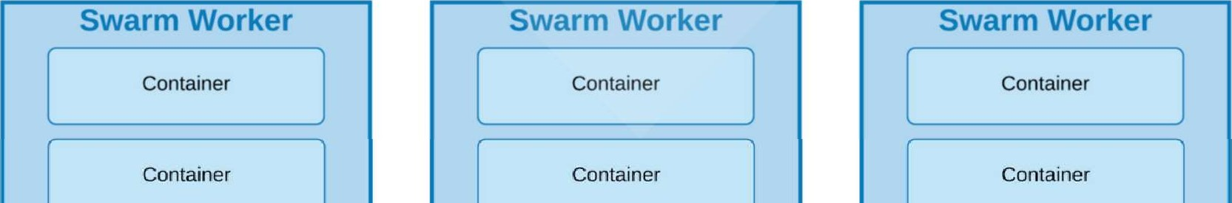

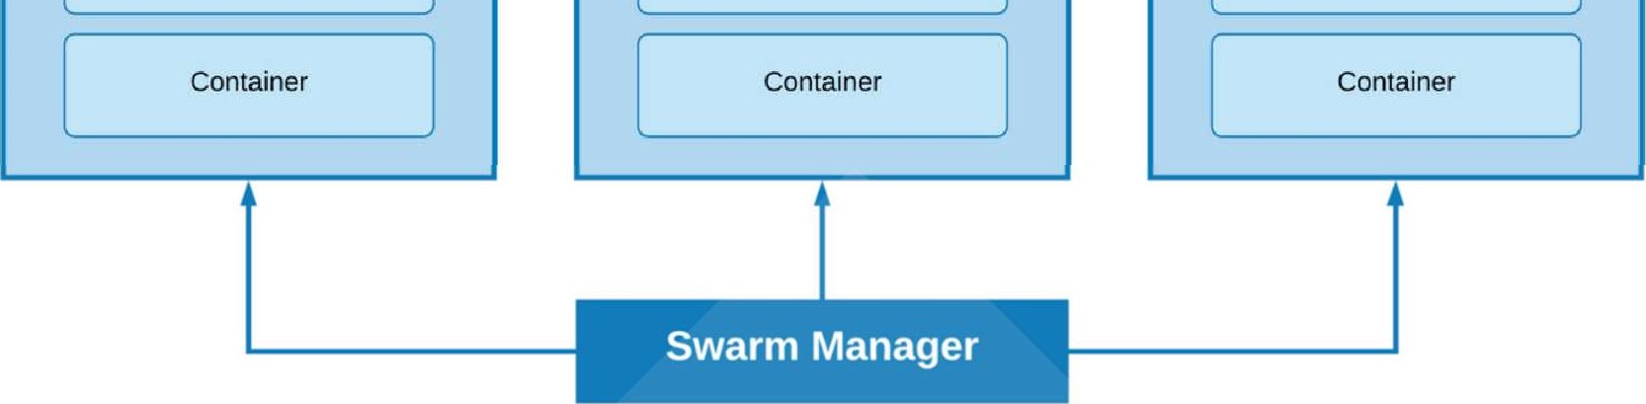

* Docker Engine helps to create Docker Swarm.
* There are mainly worker nodes and manager nodes.
* The worker nodes are connected to the manager nodes.
* So any scaling or update needs to be done first it will go to the manager node.
* From the manager node, all the things will go to the worker node.
* Manager nodes are used to divide the work among the worker nodes.
* Each worker node will work on an individual service for better performance.

DOCKER SWARM COMPONENTS:

* SERVICE: Represents a part of the feature of an application.
* TASK: A single part of work.
* MANAGER: This manages the work among the different nodes.  WORKER: Which works for a specific purpose of the service.

KEY FEATURES OF DOCKER SWARM:

Node Clustering: Docker Swarm allows you to create a group of Docker hosts that work together as a cluster. Each host in the cluster is referred to as a "node."

Service Deployment: You can define services, which are the applications you want to run, and deploy them across the Docker Swarm cluster. Docker Swarm ensures that the services are distributed and run on the available nodes.

Load Balancing: Swarm includes built-in load balancing, distributing incoming requests among the various instances of a service running on different nodes. This helps in scaling applications and improving performance.

High Availability: Docker Swarm provides high availability by automatically rescheduling tasks (individual units of a service) to healthy nodes in case of node failures.

Scalability: You can easily scale your applications by adding or removing nodes from the Swarm cluster. This allows you to adapt to changes in demand for your services.

DOCKER SWARM SETUP AND COMMANDS:

Create 3 node one is manager and another two are workers

* Manager node: docker swarm init --advertise-addr (private ip)
* Run the below command to join the worker nodes
* To check nodes on docker swarm: docker node Is (Here * Indicates the current node like master branch on git)  docker swarm leave : To down the docker node (need to wait few sec)  docker node rm node-id : To remove the node permenantly  docker swarm leave : To delete the swarm but will get error  docker swarm leave -force : To delete the manager forcefully  docker swarm join-token worker. : To get the token of the worker  docker swarm join-token manager : To get the token of the worker

DOCKER SWARM SERVICES:

Now we want to run a service on the swarm

So we want to run a specific container on all these nodes

To do that we will use a docker service command which will create a service for us

That service is nothing but a container.

We have a replicas here when one replica goes down another will work for us.

At least one of the replica needs to be up among them.

docker service create --name raham --replicas 3 --publish 80:80 httpd raham : service name replicas : nodes publish : port reference image: apache docker service Is : To list the services docker service ps service-name : To see where the services are running docker ps : To see the containers (Check all nodes once) docker service rm service_name : To remove the service (it will come again later) public ip on browser : To check its up and running or not docker service rm service-name : To remove the service

DOCKER SERVICE COMMANDS:

* To create a service: docker service create —name devops —replicas 2 image_name
* Note: image should be present on all the servers
* To update the image service: docker service update —image image_name service_name  Note: we can change image,
* To rollback the service: docker service rollback service_name
* To scale: docker service scale service_name=3
* To check the history: docker service logs
* To check the containers: docker service ps service_name
* To inspect: docker service inspect service_name  To remove: docker service rm service_name

DOCKER COMPOSE:

* It is a tool used to build, run and ship the multiple containers for application.  It is used to create multiple containers in a single host.
* it allows you to describe the services, networks, and volumes for your application in a single file, typically named docker-compose.yml.
* This file contains configurations for different services, specifying how they should be built, configured, and connected.
* It used YAML file to manage multi containers as a single service.
* The Compose file provides a way to document and configure all of the application's service dependencies (databases, queues, caches, web service APIs, etc).

KEY FEATURES OF DOCKER COMPOSE:

Services: These are the different components or containers of your application, such as a web server, a database, or any other service.

Networks: Docker Compose allows you to define custom networks for your services, enabling communication between them.

Volumes: You can specify volumes to persist data or share it between containers.

Build: Docker Compose can build custom Docker images for your services based on the configurations you provide.

DOCKER COMPOSE INSTALLATION:

* sudo curl -L "https://github.com/docker/compose/releases/download/1.29.1/dockercompose-$(uname -s)-$(uname -m)" -o /usr/local/bin/docker-compose
* Is /usr/local/bin/
*  sudo In -s /usr/local/bin/docker-compose /usr/bin/docker-compose
*  sudo chmod +x /usr/local/bin/docker-compose
*  docker-compose version

CREATING DOCKER-COMPOSE.YML•.

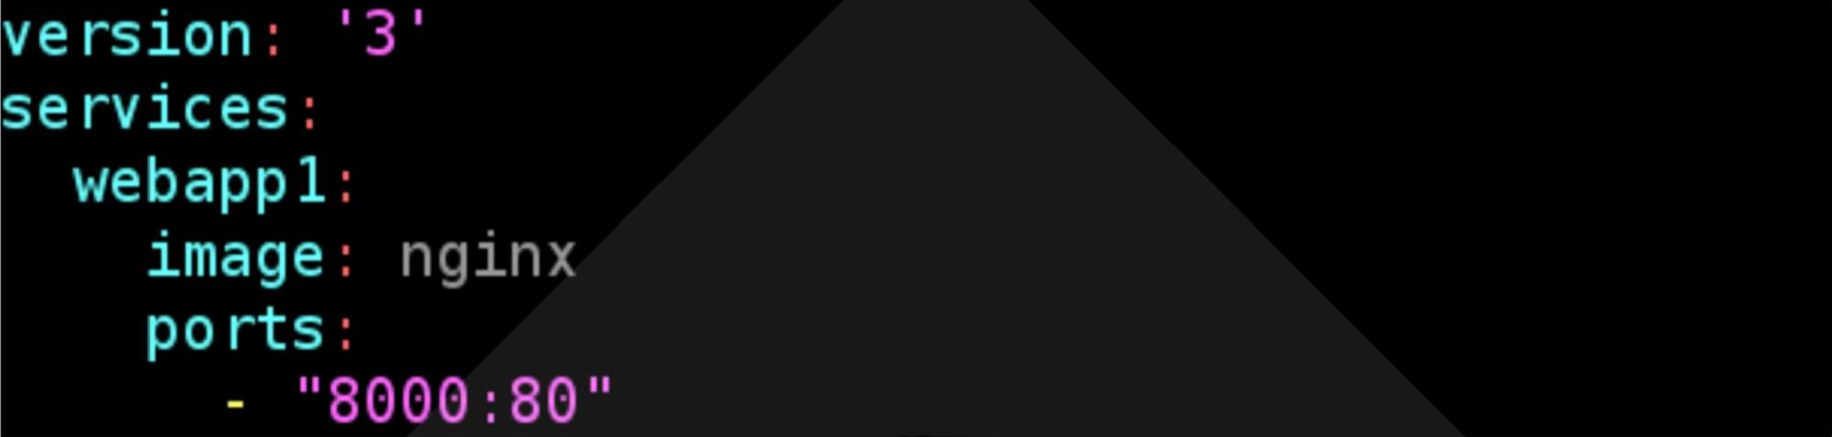

vim docker-compose.yml

Version: It is the compose file format which supports the relavent docker engine

Services: The services that we are going to use by this file (Webappl is service name)

Image: Here we are taking the Ngnix image for the webserver

Ports: 8000 port is mapping to container port 80 docker-compose up -d ------> docker compose file execution

Public-ip:8000 > You can see the Nginx image docker network Is > you can see root_default docker-compose down > It will delete all the Created containers

EX-2:

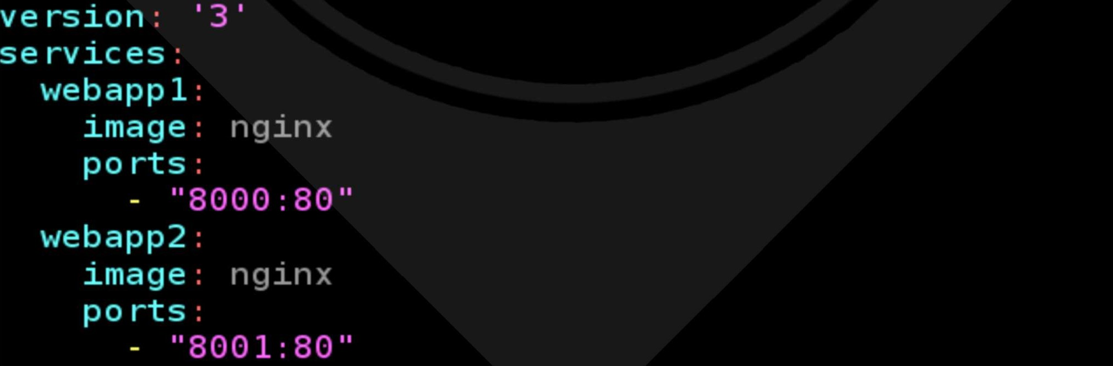

docker-compose up -d

Public-ip:8000 & public-ip:8001-- > You can see the Nginx image on both ports docker container Is docker network Is

CHANGING DEFAULT FILE:

mv docker-compose.yml docker-composel.yml docker-compose up -d

You will get some error because you are changing by default docker-compose.yml

Use the below command to overcome this error docker-compose -f docker-composel.yml up -d docker-compose -f docker-composel.yml down

EX-3:

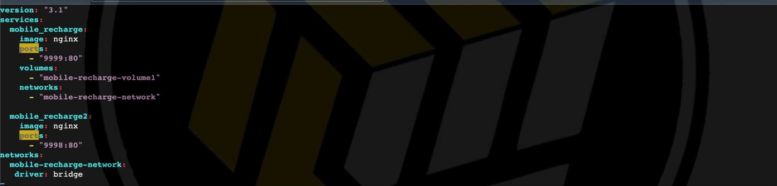

DOCKER COMPOSE COMMANDS:

* docker-compose up -d - used to run the docker file  docker-compose build - used to build the images  docker-compose down - remove the containers  docker-compose config - used to show the configurations of the compose file  docker-compose images - used to show the images of the file  docker-compose stop - stop the containers  docker-compose logs - used to show the log details of the file  docker-compose pause - to pause the containers  docker-compose unpause - to unpause the containers  docker-compose ps - to see the containers of the compose file

DOCKER STACK:

* Docker stack is used to create multiple services on multiple hosts. i.e it will create multiple containers on multiple servers with the help of compose file.
* To use the docker stack we have initialized docker swarm, if we are not using docker swarm, docker stack will not work.
* once we remove the stack automatically all the containers will gets deleted.  We can share the containers from manager to worker according to the replicas
* Ex: Lets assume if we have 2 servers which is manager and worker, if we deployed a stack with 4 replicas. 2 are present in manager and 2 are present in worker.  Here manager will divide the work based on the load on a server

DOCKER STACK COMMANDS:

* TO DEPLOY : docker stack deploy --compose-file docker-compose.yml stack_name  TO LIST : docker stack Is
* TO GET CONTAINERS OF A STACK : docker stack ps stack_name
* TO GET SERVICES OF A STACK: docker stack services stack_name  TO DELETE A STACK: docker stack rm stack_name

DOCKER INTEGRATION WITH JENKINS:

* Install docker and Jenkins in a server.

e vim /lib/systemd/system/docker.service

I servtcej

Type—notify

* + the default is not to use systemd for cgroups because the delegate issues still exists and systemd currently does not support the cgroup feature set required
  + for containers run by docker

ExecS ar = usr n oc er -H c O.O.O.O:4243 -H un x: var run oc er.soc ExecRe10ad=/btn/kt11 -s HUP SMAINPID

TimeoutSec=O

Res tartsec=2

Restart-always

* + Replace the above line with

ExecStart=/usr/bin/dockerd -H tcp://0.0.0.0:4243 -H unix:///var/run/docker.sock

* + systemctl daemon-reload  service docker restart  curl http://localhost:4243/version
  + Install Docker plugin in Jenkins Dashboard.
  + Go to manage jenkins>Manage Nodes & Clouds>>Configure Cloud.
  + Add a new cloud >> Docker  Name: Docker  add Docker cloud details.

 C A Not Secure | 6511.100.140: 8080/manage/configureClouds/ 

M Gmail O YouTube Maps EC2 Instance Con...



@ Manage Nodes

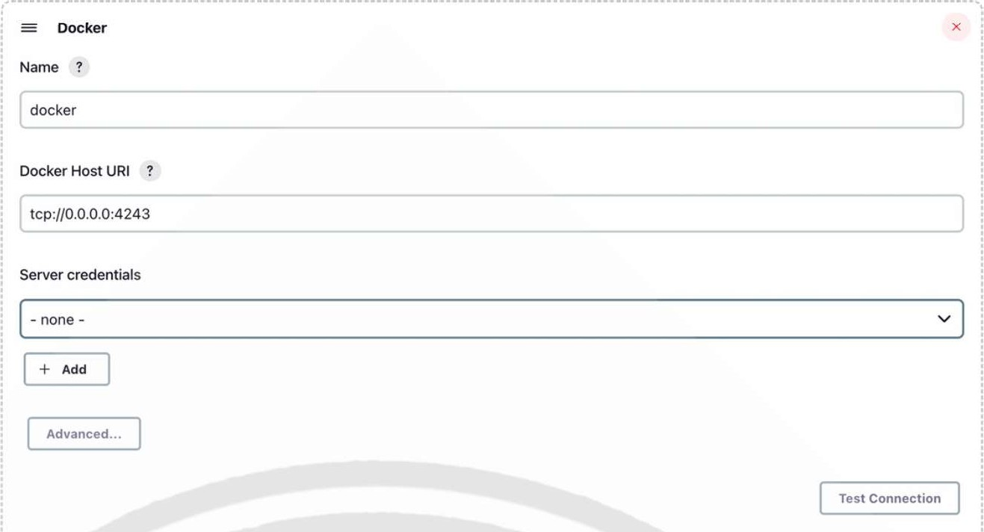

Deployment docker file:

Create 2 files:

1. Dockerfile
2. index.html file

Dockerfile consists of

FROM ubuntu

RUN apt-get update -y

RUN apt-get install apache2 -y

COPY index.html /var/www/html/

CMD ["/usr/sbin/apachectl", "-D", "FOREGROUND"]

Index.html file consists of

<hl>hi this is my web app</hl>

Add these files into GitHub and Integrate with Jenkins by declarative code pipeline.

pipeline { agent any stages { stage ("git") { steps { git branch: 'main', url: 'https://github.com/devops0014/dockabnc.git'

stage ("build") { steps {

sh 'docker build -t image77 .

stage ("container") { steps { sh 'docker run -dit -p 8077:80 image77'

You will get Permission Denied error while building the code.

To resolve that error you need to follow these steps:

* usermod -aG dockerjenkins  usermod -aG rootjenkins  chmod 777 /var/run/docker.sock  systemctl daemon-reload

Now you can build the code and it will gets deployed.

DOCKER DIRECTORY DATA:

We use docker to run the images and create the containers. but what if the memory is full in instance. we have a add a another volume to the instance and mount it to the docker engine.

Lets see how we do this.

* Uninstall the docker - yum remove docker -y  remove all the files - rm -rf /var/lib/docker/*  create a volume in same AZ & attach it to the instance  to check it is attached or not - fdisk -l  to format it - fdisk /dev/xvdf --> n p 1 enter enter w  set a path - vi /etc/fstab (/dev/xvdfl /var/lib/docker/ ext4 defaults O O)  mkfs.ext4 /dev/xvdfl  mount -a  install docker - yum install docker -y && systemctl restart docker  now you can see - Is /var/lib/docker  df -h

DOCKER PORTAINER•.

* it is a container organizer, designed to make tasks easier, whether they are clustered or not.
* able to connect multiple clusters, access the containers, migrate stacks between clusters  it is not a testing environment mainly used for production routines in large companies.
* Portainer consists of two elements, the Portainer Server and the Portainer Agent.
* Both elements run as lightweight Docker containers on a Docker engine  Must have swarm mode and all ports enable with docker engine

DOCKER PORTAINER COMMANDS:

* curl -L https://downloads.portainer.io/ce2-16/portainer-agent-stack.yml -o portaineragent-stack.yml  docker stack deploy -c portainer-agent-stack.yml portainer  docker ps  public-ip of swamr master:9000

# DOCKER

MONOLITHIC:

If an application contains N number of services (Let's take Paytm has Money Transactions,

Movie Tickets, Train tickets, etc..) If all these services are included in one server then it will be